Overview

Definition of the Problem
NE 1 L8 – CU L8R
The process of language simplification that was accelerated by the advent of the internet has reached its climax. In this scenario, the people of a certain city have completely forgotten the meaning of the letters of the alphabet and therefore can’t communicate through written or spoken language.

Objective of the Project
In order to recover the ability to communicate in this community you were designated a team whose mission was to rebuild the maximum number of letter of the alphabet as possible. This will allow the gradual return of the lost communication.
At the end, the mission should reach the following criteria:
- It should be possible to construct the phrase: “It’s difficult to put it into words”.

Goal of the Sprints
Due to the urgent need to communicate for the survival of the residents, the chosen strategy was a rapid and graduated construction of the letters that will be delivered in rapid sprints.
Each sprint must have the following goals:
Sprint | Goal
Sprint 1 | Construction of a minimum of two words with two or more letters.
Sprint 2 | Construction of a minimum of two words with four or more letters.
Sprint 3 | Construction of two complete grammatically correct sentences.
Sprint 4 | Construction of the sentence which is the object of this mission

You are not permitted to use a Word more than once in the game, but you can freely repeat the letters you have constructed, using the same letter in as many words as you want.

Initial Project Planning
The first activity to be undertaken by the team is the initial project planning. At that moment all the stories of the project must be identified and prioritized.

Sprint Planning
The project will be performed in 4 sprints that must be planned, executed and evaluated sequentially.
In order to do that, steps 3 to 6 must first be performed for the first sprint, and afterwards repeated for the following sprint until the end of the project.
To plan a sprint you should:
3.1 Confirm the goal of the sprint with your instructor.
3.2 Determine the expected velocity of the sprint. For the first sprint, the expected velocity is 25 points, and for the others it will be the actual velocity of the previous sprint.
3.3 Choose the letter to add in the sprint, sorting them in order of priority. Stop adding letters when you the total cost of the letters is equal to the expected velocity.
The assignment of stories to the current sprint is obligatory. The team can also decide to assign stories to the following sprints, but that is optional.

Sprint Execution
You know the expected velocity for the sprint and now it`s time to find the actual velocity.
4.1 Roll the dice twice.
The first die represents the gains of improving the team performance and the result must be added to the planned velocity.
The second die represents distractions and impediments that reduce the performance and must then be subtracted from the planned velocity.
Actual velocity = Expected Velocity + die (first) – die (second)
If the actual velocity is greater than planned, the team can insert new items into the sprint (new stories, correction of defects or reduction of the technical debt) until the total is complete.
But, if the actual velocity is unfortunately less than planned, the team should remove as many items as necessary. The items to be removed are those of less priority and should be postponed until the following sprint.
This actual velocity will also be the expected velocity for the next sprint.
Expected velocity (sprint x+1) = actual velocity (sprint x)

Sprint Evaluation
Were the sprint goals met? Write the response on the sprint board.

Optional rules in the game
6. Update the status reporting sheet
The team updates the status report to reflect what has occurred during the sprint.
If you are at sprint 1, 2 or 3 then go back to step 3 to plan the next sprint.
Check with the instructor at the end of each sprint to confirm your success and check for and additional instructions. Failing to update the trainer means that the sprint is invalid.

7. Ending the Project
After the sprint 4 the team should do a lessons learned session, also recording any doubts and questions.

Score sheet
Sprint number | 1 | 2 | 3 | 4
Goal | 2 words with 2 or more letters | 2 words with 4 or more letters | 2 complete sentences | Complete the sentence:  It is difficult to put it into words
Expected velocity | 25
Actual velocity
(expected + D1 – D2)
New letters
Goal achieved (yes/no)

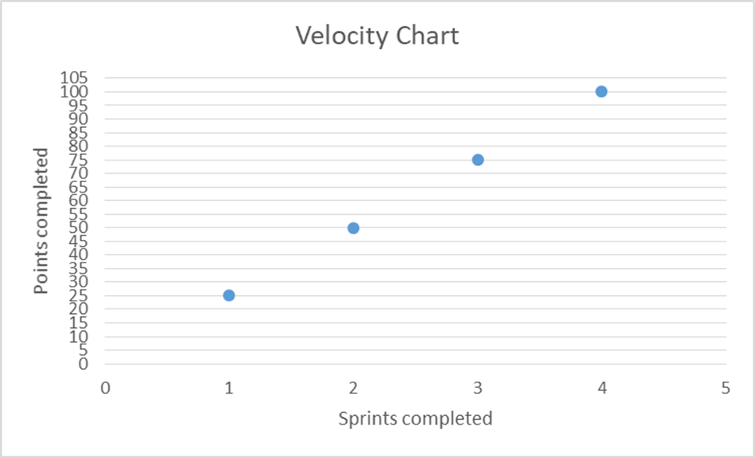

The price of the letters
8 SP | 2 SP | 5 SP | 5 SP
A | B | C | D
8 SP | 3 SP | 3 SP | 2 SP
E | F | G | H
8 SP | 2 SP | 1 SP | 8 SP
I | J | K | L
5 SP | 5 SP | 8 SP | 5 SP
M | N | O | P
3 SP | 5 SP | 5 SP | 3 SP
Q | R | S | T
8 SP | 2 SP | 1 SP | 1 SP
U | V | W | X
1 SP | 1 SP | 3 SP
Y | Z | ’

